5520: PAUL THOMAS BEVAN

1ST Bn: GLOUCESTERSHIRE REGIMENT.

Paul Thomas Bevan: (b.16/12/1881) was recently published in the Citizens “Roll of Honour”. Paul enlisted on the 6th February 1899 and also served in the Boer War as I soon discovered during 1901-3.

Sadly, Paul was killed in the early months of WWI, his death certificate dated 22/12/1914 again within a very short period of being shipped to France with the British Expeditionary Force.

PAUL THOMAS BEVAN.

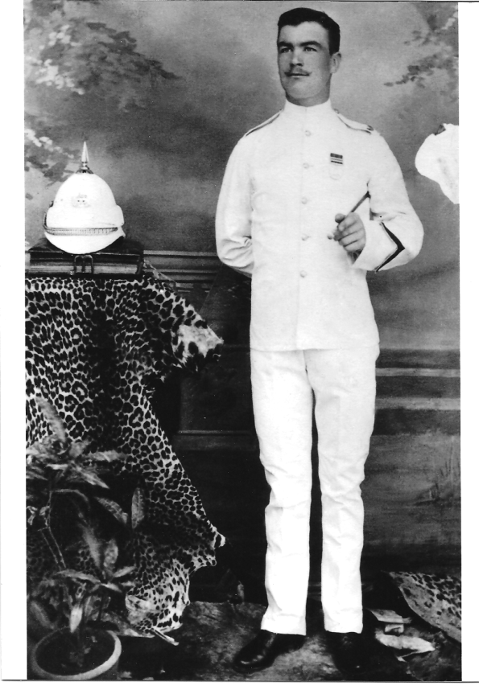

Paul was born in 1881, as his birth certificate notes – ‘Glass House Hill’ Taynton, born to parents Mary and Albert Bevan. The certificate also notes that the birth was attended by ‘Euphroysene’ Bevan, his grandmother (Married in Taynton Church).

The family lived in and around the Huntley, Taynton and Tibberton area for a number of years and Paul attended Huntley and Taynton Schools until he left in 1893. He subsequently worked as a porter for the Midland Railway until he enlisted in the army on the 6th February 1899.

Very little at present is known of his early service life, but a photograph exists of him in tropical uniform. On presenting this photograph to the curator of the Soldiers of Gloucestershire Museum, (too whom I give my thanks for their help and assistance) immediately identified his medals as being from the period 1901-3, the South African Campaign, but not where the photograph was taken.

Paul entered into the Gloucestershire Regiment Regular Army on the 6th February 1899.

He then joined at Bristol on the 8th February 1899.

The Regiment travelled to St Helena in the South Atlantic where they stayed from the 11th May 1900 – 9th January 1901.

The Regiment then travelled to South Africa with the South Africa Campaign from 10 January 1901 – 11th November 1902.

More travelling took place to India where the Regiment stayed from 12th November 1902 – 12th March 1907.

Paul was then transferred to the Reserve on 14th March 1907.

He subsequently returned to service with the Midland railway as a “Railway Goods Checker” and eventually married Fanny Causon in Birmingham, moving to 39 Albany Street, Gloucester. She gave birth to four children, Phyllis (died the same day), Francis, Edward and Ethel, (Eileen), by this time his occupation was being given as a ‘Carter’ with The Midland Railway (Birmingham and Gloucester).

Being on the Reserve List he was mobilised into the 3rd Battalion Gloucestershire Regiment on the 5th August 1914 and to France on the 11th November 1914.

He was reported Killed in Action whilst serving with the 1st Battalion Gloucestershire Regiment on the 22nd December 1914.

Little more is known of his career, even scouring the operational books of the period, sheds very little light.

His enlistment from the Reserve was in time to be shipped to France in November 1914 during the first battle of Ypres and Givenchy and the following provides, what can only be described as the last day of his life from the war diary of Lt Colonel A.C. Lovett:

An Account of 1st Battalion Gloucestershire Regt:

21st / 22nd December 1914.

*“At noon on 21st December 1914, instructions in detail were received for the attack on the East of Festubert and the 1st Battalion The Gloucestershire Regiment arrived in position at 3pm in that Village. A Company, just south of 5 in 25p map 1/40000, B & D prolonging to the left up to the proximity of the church in Festubert, C Company as support. In the advance to the attack, there was a gap on the left and touch could not be secured with the S.W.B.(South Wales Borderers)?. This gap was eventually filled by A Company Welch Regiment. C Company, under Captain Pritchett eventually was diverted to right to fill up a gap between 3rd and 1st Brigade. This Officer reached the enemy’s trenches with a few men only, not sufficient to make an entry.*

*The attack was carried out over much muddy ground and intersected with dykes that the rifles became clogged with mud and useless – bayonets could* ***not*** *be fixed. No reply could be made to the hostile fire and the line could not push within 300yds of the enemy’s position as they were under heavy machine gun fire and rifle fire and losses became very heavy. Here the Battalion entrenched during the night on a front of about 300yds.*

*On the morning of the 22nd December in the early morning, a lookout was kept for the advance of the Royal Munster Rifles on the right, but nothing was seen of them moving, although during the night RMF Headquarters were located and visited. The entrenchment was continued and improved.*

*Captain and Acting Adjutant Bosanquet was invaluable in assisting to direct the companies in their advance on the 21st, under heavy fire.*

*No: 5957 Lance Corporal Bailey and N0: 9796 H. Mann remained with Captain Pritchett, when that Officer was severely wounded within 25yds of the enemy’s trench from the night of the 21st until early morning of the 23rd when Captain Pritchett was brought back. They placed their Officer, under close fire of the enemy in a place of comparative safety.*

Casualties of that day: 16 killed, 86 wounded and 94 missing.

Ordered to continue the attack at dawn. The attack was cancelled later.

Subsequently on the 27th December, to this action, a letter was received by Lieutenant-Colonel Lovett from Sir Douglas Haig expressing his appreciation of the excellent work done by the 1st Division on the 21st and 22nd December in exceptionally difficult circumstances: -

* The 1st Battalion Gloucestershire Regiment, in conjunction with –
* 1st Battalion Coldstream Guards
* 2nd Battalion Welch Regiment
* 2nd Battalion Royal Munster Regiment

“Sir Douglas Haig read the reports with great pleasure. The First Division fully maintained the high reputation, which it had already won”.

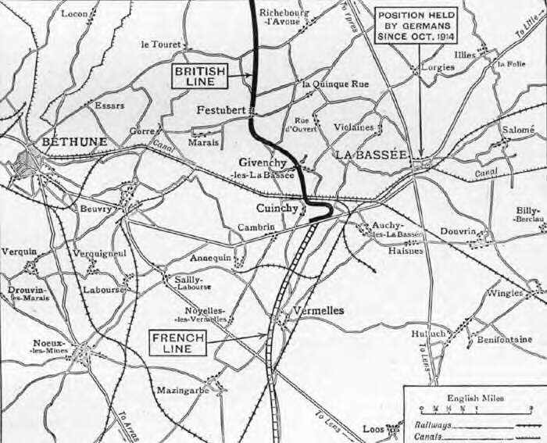

Paul Thomas Bevan has no known grave. He is however, commemorated at:

St James Church, Upton Street, Gloucester (Roll of Honour).

The City of Gloucester War Memorial, WWI / WWII. Park Road, Gloucester.

The Rolls of Honour for the Fallen at Gloucester Cathedral.

The Commonwealth War Graves Commission War Memorial, Le Touret, France.

His daughter also had his name engraved on his wife’s grave at Aschurch (Tewkesbury)

(“Within the sound of the ‘Down’ to Bristol from Birmingham or the ‘Up’ from Bristol to Birmingham”). (ex: Midland Railway)

The Midland Railway Roll of Honour (Derby Station).

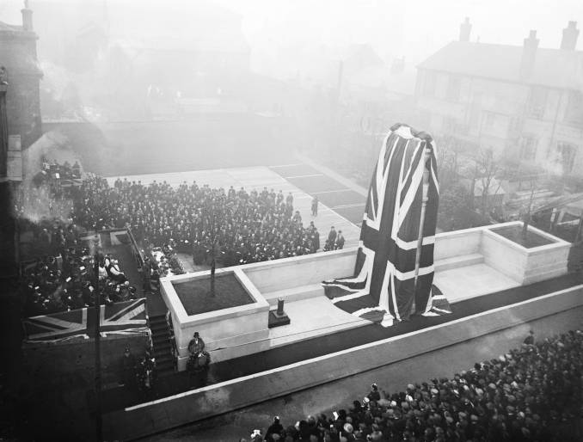

## The Memorial was designed by Sir Edward Lutyens and originally dedicated on the 15th December 1921.

“To the memory of the 2,833 brave men of The Midland Railway staff

who gave their lives in the Great War”.

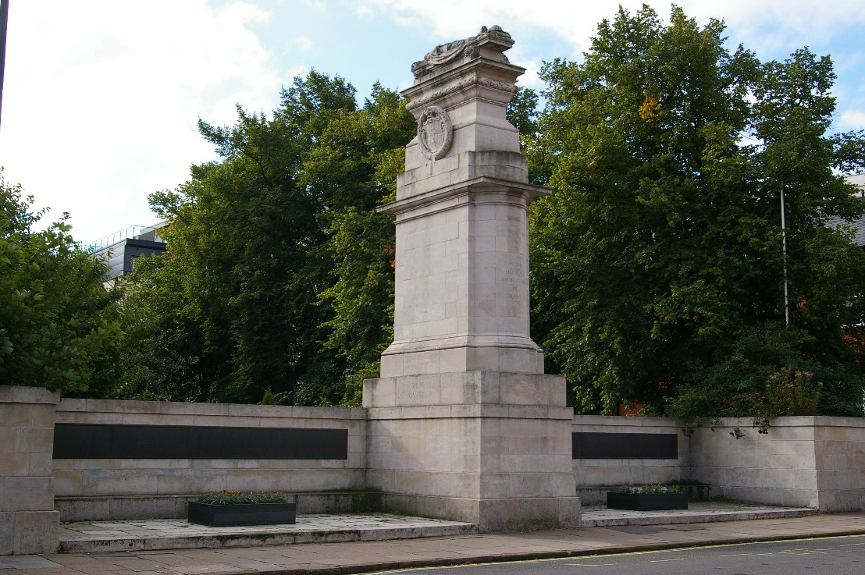

## In Memory of Private PAUL THOMAS BEVAN

## 5520, 1st Bn., Gloucestershire Regiment

## who died age 33 on 21 December 1914

## Husband of Fanny Bevan, of 39, Albany St., Gloucester.

## Remembered with honour CWGC LE TOURET MEMORIAL

## letouret Commemorated in perpetuity by the Commonwealth War Graves Commission

And of the family:

Fanny Bevan subsequently remarried in 1921, to have a son Stanley Arthur Whiting, tragically killed in a flying accident in August 1942, which is another story.

Francis (Frank) Thomas Bevan trained as a Jig and Tool engineer/draughtsman and although in a ‘Reserved’ occupation during WWII, was a member of The Rotol Bomb Disposal Squad. He subsequently joined the TA with REME at Bearland. Frank died in a car accident in 1970. His widow, Barbara, at 103, lives in Gloucester.

Eileen Bevan worked in the War Office during WWII, married and now widowed and lived in Gloucestershire also survived to be 101+ years old. Sadly, she has now died (June 2014).

Edward (Ted) Bevan became a despatch rider during WWII and was (apparently) one of the first British soldiers to enter Belsen Concentration Camp at the end of the war. He consequently worked as a maintenance engineer (Carpenter and Joiner) for Rotol / Dowty.

Service life lives on in the Bevan Family as the great grandson, Oliver of Paul Thomas Bevan served as a Captain, with:

The Argyll and Sutherland Highlanders.

5 Scots, The Royal Regiment of Scotland

Served with distinction on two tours of Afghanistan and subsequently left the army in October 2012, now a (Major) with 6 Rifles ‘Reserve’ Force OTC Birmingham University.

Philip S Bevan

(01452) 790424